**The Twelve Signs**

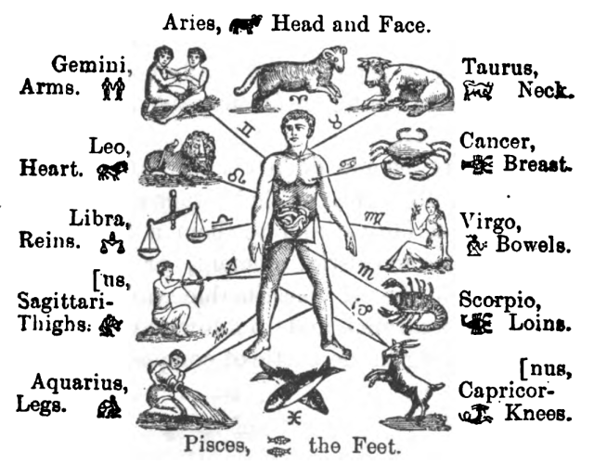The Twelve Signs of the Zodiac (M. M. Shoemaker, 1904)

In astrology, the zodiac wheel of twelve signs is a symbolic representation of the heavens, subdivided into twelve equal 30° parts based on the ecliptic, or the Path of the Sun over the course of a year, with one year marked by the 360° cycle.

The zodiac wheel is rooted in the motion of the Sun, Moon, and planetary bodies along that ecliptic, forming a beltway, and this zodiac belt encompasses the constellations that lie along the Path. Twelve constellations, forming this zodiac belt, are the backbone of the wheel. In Hellenistic astrology, these signs as divisions mark space, rather than time, and are not *literal*constellations (*compare*: a sidereal chart depicting the actual divisions of the zodiac belt based on time).

Thus, this division of twelve signs is the Tropical zodiac, tied to the seasons rather than the actual timed cycle of the constellations themselves. Aries marks the vernal equinox, at the point when the Sun crosses the celestial equator moving northward; Cancer marks the summer solstice; Libra marks the autumnal equinox; and Capricorn marks the winter solstice.

The earliest recording of the twelve zodiac signs is dated to around 700 BC and found in Babylonian astronomy. The path of the sun in the heavens as observed from a geocentric point of view was subdivided into twelve equal coordinate zones. The first Babylonian calendar was keyed to the twelve signs, with the positioning of the sun during the vernal equinox marking the first sign, or Aries (known historically as the First Point of Aries).

[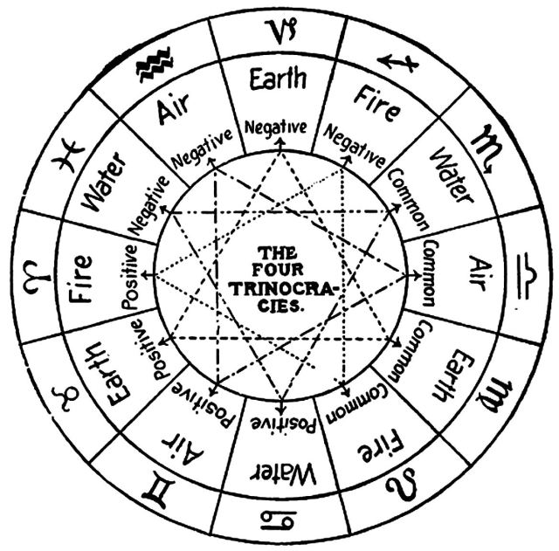](https://benebellwen.com/wp-content/uploads/2015/10/from-practical-astrology-a-simple-method-of-casting-horoscopes-1901-by-comte-c-de-saint-germain-p22.jpg)From Practical Astrology A Simple Method of Casting Horoscopes (1901) by Comte C. de Saint-Germain, page 22

In the Babylonian star catalogs, the twelve signs were assigned names, which have become the predecessors of the names we ascribe to the twelve zodiac signs today.

[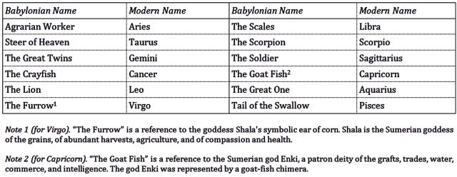](https://benebellwen.com/wp-content/uploads/2015/10/twelve-zodiac-signs-babylonian-names.jpg)Click chart image for enlarged viewing.

The zodiac signs are subdivided into triplicities in four groupings per their elemental qualities:

|  |  |  |
| --- | --- | --- |
| **Fire** signs | Aries, Leo, Sagittarius | ASSERTIVE | Dynamic, passionate, fully energized |
| **Earth** signs | Taurus, Virgo, Capricorn | RECEPTIVE | Grounded, pragmatic, stabilizing |
| **Air** signs | Gemini, Libra, Aquarius | ASSERTIVE | Social, intelligent, agile, perceptive |
| **Water** signs | Cancer, Scorpio, Pisces | RECEPTIVE | Emotionally attuned, intuitive, sensitive |

The signs are further classified into quarternaries in three groupings per the core energy that drives their respective elemental qualities:

* **Cardinal**: Initiators. Action-oriented. Spark, inspire, excel, to pilot. *Aries, Cancer, Libra, Capricorn*.
* **Fixed**: Stabilizers. Sustainability-oriented. Preserve, to protect. *Taurus, Leo, Scorpio, Aquarius*.
* **Mutable**: Changemakers. Progress-oriented. The resistance; to adapt. *Gemini, Virgo, Sagittarius, Pisces*.

With each sign balanced as one in three of four sets and also one in four of three sets, a balanced system emerges, with each specific formula of balance producing a cosmic archetype, a pattern of life experiences, an expression of cosmic change, or how change is produced.

Thus, for example, Mercury in Sagittarius is more dynamic than Mercury in Pisces where it is more sensitive, but since both Sagittarius and Pisces are Mutable signs, both of such natives tend to be changemakers and progress-oriented. Compare, for instance, Jupiter in Libra is more agile from the Air elemental, and an initiator of excellence per its Cardinal quality, but Jupiter in Gemini, also an Air elemental, is similarly agile in mind, but more attuned to resistance than to sovereignty.

The sequence of the twelve zodiac signs from Aries to Pisces also mark the narrative of life cycles and the human experience: the transition into each sign marks key lessons and challenges for the soul to learn from. For balance, each sign has an opposite polarity, and so in Aries, the lesson is personal identity and individual will, whereas the polar opposite in Libra, the lesson is harmonizing with the group; Cancer is about home, family, and one’s inner life, while its polarity Capricorn is about career, social standing, and one’s public life.

[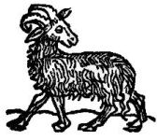](https://benebellwen.com/wp-content/uploads/2022/10/1700s-wood-cut-aries.jpg)

**Aries**

MARCH 21 – APRIL 19

The Warrior. The Innovator. The Sovereign.

***The Aries Mission:***  
To lead the way for others;  
To conquer;  
To be a force of nature;  
To be a pioneer;  
To be innovative;  
To be self-reliant;  
To enjoy the thrill of a moment;  
To stand out and be noteworthy.

*Expression and Influences*: Involving initiations, new beginnings; plants the first seed; exerts strong personal willpower, possessing a strong sense of identity, confident, aggressive, assertive, seeking glory; native is ambitious, determined, and takes the initiative when it comes to this area of life; short fuse or bad temper; can have a short attention span when it comes to this area of life.

*Characteristic Traits*: Headstrong, bold, decisive, born to lead, shows great initiative, need for conquest, enterprising, intrepid, passionate, arrogant, stubborn, impulsive, can be difficult to work with, egotistical.

*Strongest Dignities*: Natal Sun in Aries; Mars in Aries; Pluto in Aries; in House 1, 5, or 9; also strong in House 3, 7, or 11. These are areas where Aries exerts a more constructive influence.

*Weakest Dignities*: Natal Venus in Aries; Saturn in Aries; in House 4, 8, or 12. These are areas where Aries may exert a more challenging influence.

[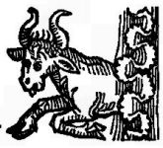](https://benebellwen.com/wp-content/uploads/2022/10/1700s-wood-cut-taurus.jpg)

**Taurus**

APRIL 29 – MAY 20

The Steer of Heaven. The Builder. The Architect. The Organizer.

***The Taurean Mission:***  
To establish emotional security  
To establish financial security  
To bring growth and expansion  
To manifest self-substantiation  
To be pragmatic and self-sustaining

*Expression and Influences*: Material acquisitions; power to build strong foundations; involving land, nature, the earth, or estates; motivated by material desires; seeks control over land and earth; traditional; conservative and risk averse; practical; assets, money, commerce, or trade oriented; ambitious; high-achieving but cautious.

*Characteristic Traits*: Seeks security and stability; practical; powerful; independent; stubborn; forceful; sensual; a natural eye for beauty, and the arts and culture; loyal, but possessive, can be lazy or self-indulgent; frugal.

*Strongest Dignities*: Natal Moon in Taurus; Venus in Taurus; in House 2, 6, or 10; also strong in House 4, 8, or 12. These are areas where Taurus exerts a more constructive influence.

*Weakest Dignities*: Natal Mars in Taurus; Uranus in Taurus; Pluto in Taurus; in House 3, 7, or 11. These are areas where Taurus may exert a more challenging influence.

[](https://benebellwen.com/wp-content/uploads/2022/10/1700s-wood-cut-gemini.jpg)

**Gemini**

MAY 21 – JUNE 20

The Great Twins. The Trickster. The Truth Speaker. The Visionary.

***The Gemini Mission:***  
To impress;  
To explore diverse interests;  
To get ahead of the crowd;  
To enjoy life as a jack of all trades;  
To have many options;  
To acquire multiple skill sets;  
To be seen as multi-talented;  
To think.

*Expression and Influences*: Expressive, flexible and adaptable; involving siblings, twins, or multiple personalities or multiple approaches; multiples; changeable; many changes and shifts will be experienced in the corresponding area of life; fluctuating; situations involving this area of life are unpredictable, changeable, and ever shifting; short distance travels will be productive for this area of life; expressive and communicative; cerebral; many initiations few completions.

*Characteristic Traits*: Unpredictable, adaptable to changes, versatile, multi-talented, persuasive, witty, intellectual, conversational, can be capricious, too many ideas and not enough execution; volatile, changeable; lacks focus; gives a strong first impression but no follow-through; frenetic energy; indecisive; curios and inquisitive.

*Strongest Dignities*: Natal Mercury in Gemini; in House 3, 7, or 11; also strong in House 1, 5, or 9. These are areas where Gemini exerts a more constructive influence.

*Weakest Dignities*: Natal Jupiter in Gemini; in House 2, 6, or 10. These are areas where Gemini may exert a more challenging influence.

[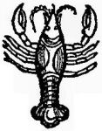](https://benebellwen.com/wp-content/uploads/2022/10/1700s-wood-cut-cancer.jpg)

**Cancer**

JUNE 21 – JULY 22

The Nurturer. The Mystic. The Defender.

***The Cancerian Mission:***  
To find intimacy;  
To seek reassurance;  
To feel safe;  
To find meaning through spirituality;  
To find meaning through love;  
To find home.

*Expression and Influences*: Constructive use of intuition and sentimentality in corresponding area of life; where one can be more intuitive; motivated by home and family; emotional; private; relating to ancestry, heritage, or lineage; hidden treasures; self-preservationist; where one seeks spiritual understanding or meaning.

*Characteristic Traits*: Complicated individual; fundamentally conservative, home-loving; intuitive; loving; protective over one’s personal space and loved ones; tough outer shell to break; moody, timid, pessimistic; emotionally sensitive; empathic.

*Strongest Dignities*: Natal Moon in Cancer; Jupiter in Cancer; Neptune in Cancer; in House 4, 8, or 12; also strong in House 2, 6, or 10. These are areas where Cancer exerts a more constructive influence.

*Weakest Dignities*: Natal Mars in Cancer; Saturn in Cancer; in House 1, 5, or 9. These are areas where Cancer may exert a more challenging influence.

[](https://benebellwen.com/wp-content/uploads/2022/10/1700s-wood-cut-leo.jpg)

**Leo**

JULY 23 – AUGUST 22

The Monarch. The Baron. The Radiant One. The Charismatic. The Entertainer.

***The Leo Mission:***  
To lead the way;  
To motivate and be motivated;  
To be a star;  
To manifest creativity in your work products;  
To seek personal glory;  
To seek validation;  
To gain recognition for your creative work.

*Expression and Influences*: Glory-seeking; leadership; nobility; seeking happiness and romance; creativity; a lot of pride for achievements in the corresponding area of life; bold and courageous; seeking attention; where one tends to dominate, where one tends to shine.

*Characteristic Traits*: A powerful leader; big-hearted and magnanimous; needs to be the center of attention; seeks fame and glory; optimistic; strong in performing arts; action-oriented; self-confident, can become overly proud of self; vanity; intense.

*Strongest Dignities*: Natal Sun in Leo; Neptune in Leo; in House 1, 5, or 9; also strong in House 3, 7, or 11. These are areas where Leo exerts a more constructive influence.

*Weakest Dignities*: Natal Saturn in Leo; Uranus in Leo; in House 4, 8, or 12. These are areas where Leo may exert a more challenging influence.

[](https://benebellwen.com/wp-content/uploads/2022/10/1700s-wood-cut-virgo.jpg)

**Virgo**

AUGUST 23 – SEPTEMBER 22

The Craftsman. The Scholar. The Truth Seeker.

***The Virgoan Mission:***  
To do the right thing;  
To devise the best plan;  
To be methodical in all ways;  
To deliberate and adjudicate with care;  
To love and be loved in return.

*Expression and Influences*: Strives for perfectionism; relating to health or healing; servitudes; where one is restricted; obstacles; emotionally unavailable; holding oneself back due to being risk averse; fear of vulnerability; hermit-like or introverted tendencies in that area of life; where one tends to be more suppressed.

*Characteristic Traits*: Highly intelligent and meticulous; discriminating tastes; detail-oriented; analytical; highly critical of self and of others; reliable; health-conscious; down-to-earth; fussy, fastidious; sensitive; finicky; judgmental, conservative; difficult to please.

*Strongest Dignities*: Natal Mercury in Virgo; in House 2, 6, or 10; also strong in House 4, 8, or 12. These are areas where Virgo exerts a more constructive influence.

*Weakest Dignities*: Natal Venus in Virgo; Jupiter in Virgo; Neptune in Virgo; Pluto in Virgo; in House 3, 7, or 11. These are areas where Virgo may exert a more challenging influence.

[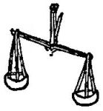](https://benebellwen.com/wp-content/uploads/2022/10/1700s-wood-cut-libra.jpg)

**Libra**

SEPTEMBER 23 – OCTOBER 22

The Scales. The Aristocrat. The Judge. The Mediator.

***The Libran Mission:***  
To find true love;  
To be consistent;  
To live an easy, uncomplicated life;  
To quest for the Holy Grail;  
To restore balance where there is imbalance.

*Expression and Influences*: Seeking balance and harmony in corresponding area of life; multi-talented and knowledgeable when it comes to that area of life; values arts and culture; seeking diplomacy; partnerships, contracts, legal issues; social associations; tendency to be indecisive in this area of life.

*Characteristic Traits*: Diplomatic, fair, just; sociable, romantic, charming; tactful, even-handed; can be over-compromising; tries too hard to appease all; innately attractive; can be superficial, unreliable, or indecisive; self-indulgent; good counselor, good at giving advice; impartial opinions; has difficulty saying “no.”

*Strongest Dignities*: Natal Venus in Libra; Saturn in Libra; in House 3, 7, or 11; also strong in House 1, 5, or 9. These are areas where Libra exerts a more constructive influence.

*Weakest Dignities*: Natal Sun in Libra; Mars in Libra; Pluto in Libra; in House 2, 6, or 10. These are areas where Libra may exert a more challenging influence.

[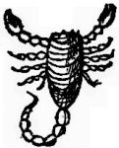](https://benebellwen.com/wp-content/uploads/2022/10/1700s-wood-cut-scorpio.jpg)

**Scorpio**

OCTOBER 23 – NOVEMBER 21

The Insurgent. The Shapeshifter. The Investigator. The Challenger.

***The Scorpion Mission:***  
To unlock mysteries;  
To investigate;  
To triumph;  
To survive against all opposition;  
To perfect the art of seduction;  
To wield great power.

*Expression and Influences*: High-achieving toward this area of life; intense; many secrets; concealing true identities; the esoteric and the occult; sensual; seeking power; risk-taking; passionate; physical external crises and transformations incurred in this area; legacies; desirous; high ambitions; some arrogance; may go through one major, emotional shift in corresponding area of life.

*Characteristic Traits*: Intense, strong-willed, fearless, determined, poised, demanding, penetrating perception, possesses the power to confront; gets attention for accomplishments; sensitive and passionate; intuitive, secretive, can be resentful of others; destructive, overly dramatic, vengeful.

*Strongest Dignities*: Natal Mars in Scorpio; Uranus in Scorpio; Pluto in Scorpio; in House 4, 8, or 12; also strong in House 2, 6, or 10. These are areas where Scorpio exerts a more constructive influence.

*Weakest Dignities*: Natal Moon in Scorpio; Venus in Scorpio; in House 1, 5, or 9. These are areas where Scorpio may exert a more challenging influence.

[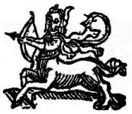](https://benebellwen.com/wp-content/uploads/2022/10/1700s-wood-cut-sagittarius.jpg)

**Sagittarius**

NOVEMBER 22 – DECEMBER 21

The Sage. The Explorer.

***The Sagittarian Mission:***  
To live the good life;  
To seek adventure;  
To embrace the path of a free spirit;  
To make a difference in the world;  
To seek spiritual expansion;  
To seek knowledge and truth.

*Expression and Influences*: Seeking expansion, diversity of experiences, and broadening personal horizons; higher education; active imagination; hunter-mentality; hunter-prey dynamics; ambitious; risk-taking in this area of life; spiritual; seeking higher ideals; faith; long-distance travels bring fruition; foreign lands; pilgrimage or inner spiritual journey for self-knowledge in corresponding area of life.

*Characteristic Traits*: Intellectual, idealistic, witty, free-spirited, has a bright and optimistic outlook; can be careless and tactless; adventurous, goal-seeking, enthusiastic; can be reckless and unrestrained toward others; arrogant; overly confident with self; too much restlessness; non-committal; inconsistent; dislikes boundaries; philosophical, generous, and giving.

*Strongest Dignities*: Natal Jupiter in Sagittarius; in House 1, 5, or 9; also strong in House 3, 7, or 11; also strong in House 1, 5, or 9. These are areas where Sagittarius exerts a more constructive influence.

*Weakest Dignities*: Natal Mercury in Sagittarius; in House 4, 8, or 12. These are areas where Sagittarius may exert a more challenging influence.

[](https://benebellwen.com/wp-content/uploads/2022/10/1700s-wood-cut-capricorn.jpg)

**Capricorn**

DECEMBER 22 – JANUARY 19

The Overachiever. The Governor. The Pragmatist. The Financier. The Plutocrat.

***The Capricornus Mission:***  
To excel;  
To be proud of their achievements;  
To be admired by their family and friends;  
To be admired by the world at large;  
To seek ascension, always;  
To scale new heights of status.

*Expression and Influences*: Seeking to scale new heights; proud of accomplishments; seeking glory; seeking to transcend past and be better than the previous; aiming high; seeking higher social status, power, or public esteem in corresponding area of life; seeking advancements in that area of life; where one is more ambitious and represents the themes of one’s life goals.

*Characteristic Traits*: High achieving, goal-oriented, results-oriented, pragmatic, disciplined, stable, conservative, modest, prudent, can be callous and pessimistic; stubborn, introverted, self-centered, detached, moody; inability to express the self; seeks achievement rather than self-knowledge; rigid in values and ideologies; can be materialistic; may lack imagination or creativity; always steadfast, reliable, and trustworthy.

*Strongest Dignities*: Natal Mars in Capricorn; Saturn in Capricorn; in House 2, 6, or 10; also strong in House 4, 8, or 12. These are areas where Capricorn exerts a more constructive influence.

*Weakest Dignities*: Natal Moon in Capricorn; Jupiter in Capricorn; Neptune in Capricorn; in House 3, 7, or 11. These are areas where Capricorn may exert a more challenging influence.

[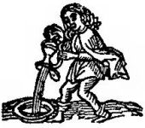](https://benebellwen.com/wp-content/uploads/2022/10/1700s-wood-cut-aquarius.jpg)

**Aquarius**

JANUARY 20 – FEBRUARY 18

The Teacher. The Eccentric. The Advocate. The Diplomat.

***The Aquarian Mission:***  
To understand life’s mysteries;  
To serve the greater good;  
To be a champion of social justice;  
To be unique and original;  
To march to the beat of your own drum;  
To know, to learn, and to understand what it all means.

*Expression and Influences*: Humanitarian, devotional, spiritual; eccentric and unconventional; marching to beat of own drum; where one seeks to contribute to the greater good; where one seeks change and progress; involving collective or group endeavors.

*Characteristic Traits*: Highly intelligent, amicable, friendly, humanitarian, innovative, possesses a lot of ingenuity, progressive, group-conscious; strong and attractive, forceful, possesses tremendous personal power; popular, intelligent, unpredictable, rebellious, eccentric, aloof, emotionally superficially or unavailable; can be an extremist when incited; stubborn; energies of Higher Thought.

*Strongest Dignities*: Natal Saturn in Aquarius; Uranus in Aquarius; in House 3, 7, or 11; also strong in House 1, 5, or 9. These are areas where Aquarius exerts a more constructive influence.

*Weakest Dignities*: Natal Sun in Aquarius; Neptune in Aquarius; in House 2, 6, or 10. These are areas where Aquarius may exert a more challenging influence.

[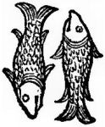](https://benebellwen.com/wp-content/uploads/2022/10/1700s-wood-cut-pisces.jpg)

**Pisces**

FEBRUARY 19 – MARCH 20

The Martyr. The Messiah. The Dreamer.

***The Piscean Mission:***  
To avoid feeling alone;  
To feel connected to others;  
To connect to the world at large;  
To live your dreams;  
To turn fantasies into realities;  
To adapt to any situation;  
To be a chameleon, resilient—a survivor.

*Expression and Influences*: Difficulties and challenges as pertaining to emotions felt toward corresponding area of life; fluctuations; indecisiveness; self-sacrificing, passive, and too yielding in corresponding area of life; crises, revelations, and epiphanies to be experienced in that area of life; karmic lesson for this life path is to gain self-knowledge and reveal the hidden self in this area.

*Characteristic Traits*: Sensitive, self-sacrificing, intuitive, values human relations, creative, possesses a vivid imagination; may swing between planes of reality and spiritualism; mysterious, sensual, romantic, emotional; great at conceptual or abstract thought; compassionate, empathic; sensitive, yielding to others; an escapist and idealist; can be lazy or weak-willed (gets hurt easily; gets demoralized easily), overly sensitive, hyper-sensitive to criticism, impractical.

*Strongest Dignities*: Natal Jupiter in Pisces; Neptune in Pisces; Pluto in Pisces; in House 4, 8, or 12; also strong in House 2, 6, or 10. These are areas where Pisces exerts a more constructive influence.

*Weakest Dignities*: Natal Mercury in Pisces; in House 1, 5, or 9. These are areas where Pisces may exert a more challenging influence.

line

**Medieval Medical Astrology: Health and the Zodiac Signs**

[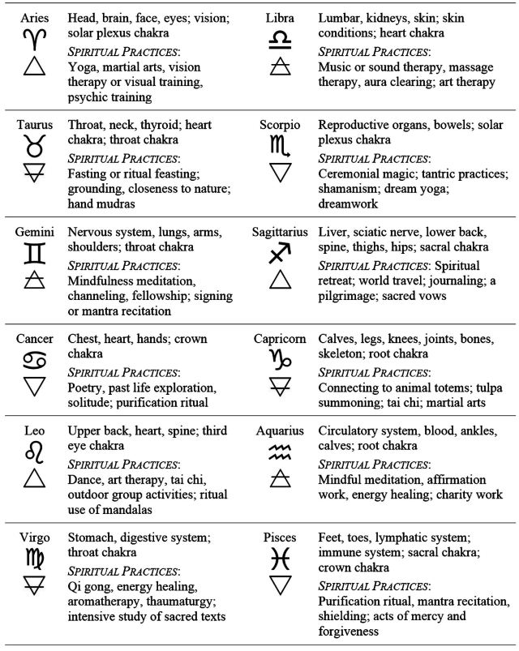](https://benebellwen.com/wp-content/uploads/2022/10/zodiac-signs-and-health-medical-astrology.jpg)

Per medieval medical astrology, the twelve zodiac signs correspond with parts of the body, head to toe. In modern astrology, certain types of spiritual practices are also attributed to the twelve signs. In totality, the above reference table provides both physical and spiritual health correspondences.

line

[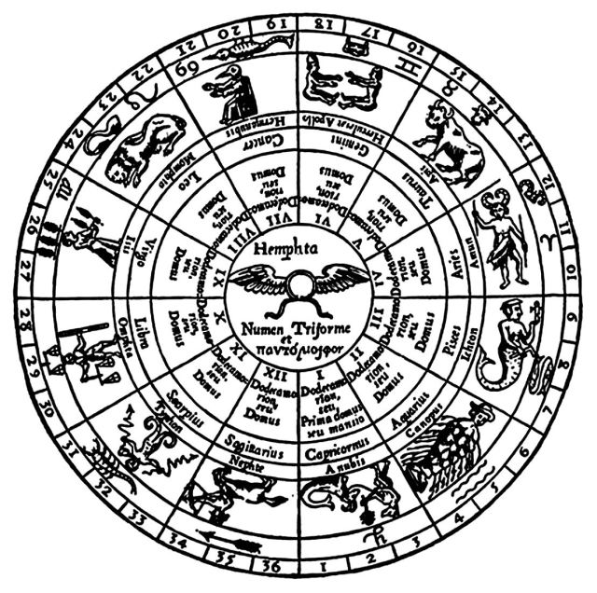](https://benebellwen.com/wp-content/uploads/2015/10/from-athanasius-kircher-oedipus-aegyptiacus-1652-titled-hermes-hieroglyphic-plan-of-the-ancient-zodiac.jpg)“Hermes Hieroglyphic Plan of the Ancient Zodiac” from Athanasius Kircher Oedipus Aegyptiacus (1652)

In addition to what you’ve read here, be sure to download the below free resource.

[**Learning the Twelve Astrological Signs (PDF)**](https://benebellwen.com/wp-content/uploads/2016/09/learning-the-twelve-astrological-signs-2016-09-16.pdf)

This document is intended for astrology beginners. It was one of the supplements from my “Learning the Opening of the Key” tarot course provided through the Tarot Readers Academy.